Subject: Be Part of this National Church/Parish Survey

Imagine if all churches could be strengthened across Canada, ours included. Our congregation has partnered with the Flourishing Congregations Institute to be part of this transformation, and we would like your help!

Please take 20 minutes to fill out the online survey [insert congregation-specific link]. Encourage those you know to do the same. Please know that no one in our church will have access to individual responses. Fill out the survey in the next month and be entered into a draw for a $50 Amazon gift card.

We hope for 50% or more of our adult attenders to fill out the survey. With strong survey involvement from those in our congregation/parish, we will receive uniquely helpful information about our own congregation/parish that we can use as we seek to flourish and faithfully minister in our particular context.

To learn more about the survey, the larger project, and many of the anticipated benefits to arise, visit: flourishingcongregations.org/surveys.

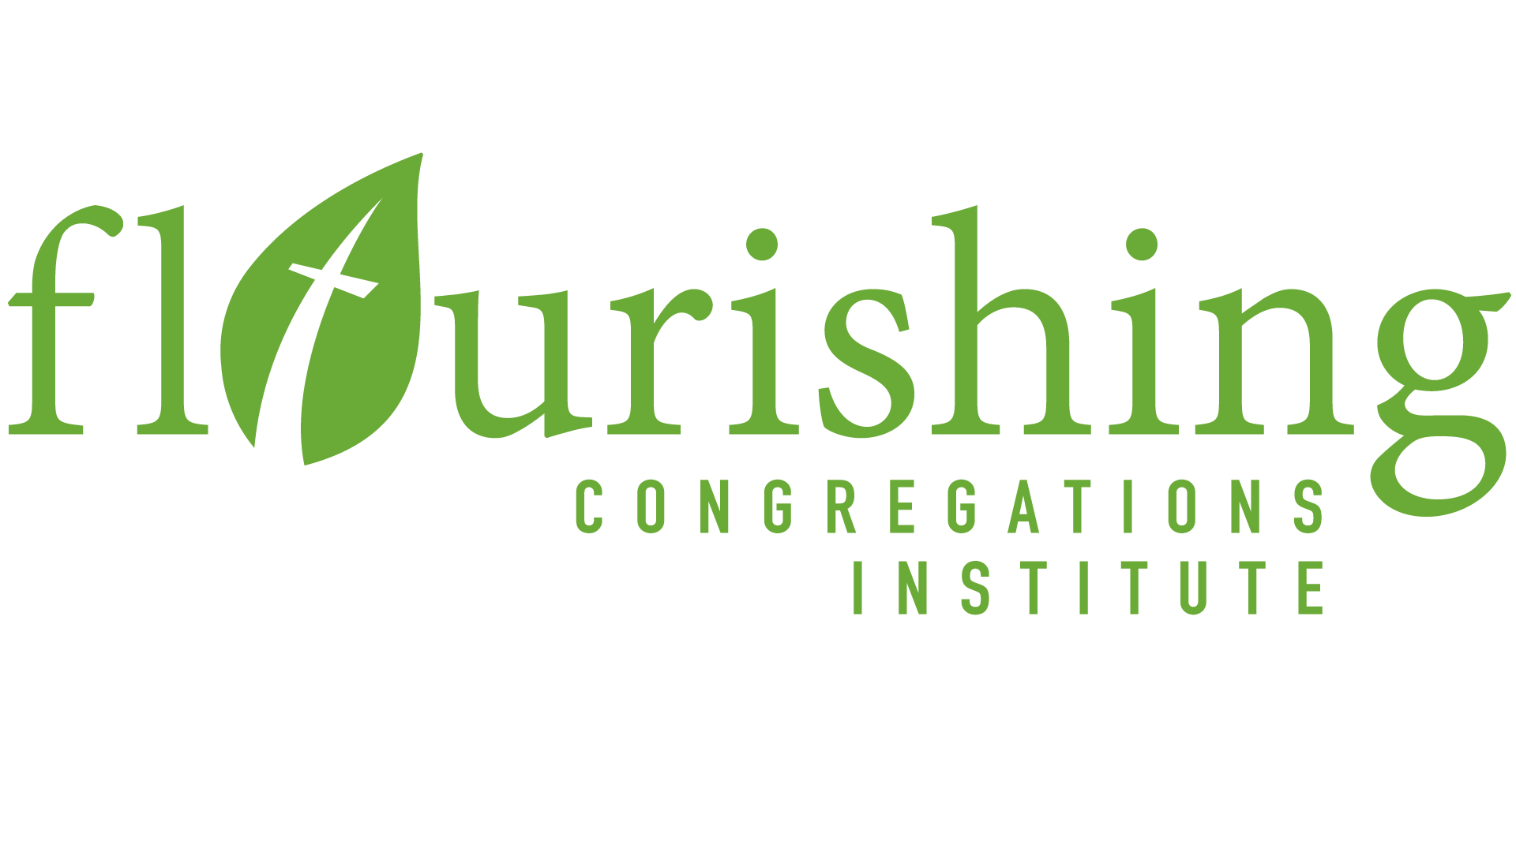
Thanks, in advance, for completing this survey!

