Imagine if all churches could be strengthened across Canada, ours included. Our congregation has partnered with the Flourishing Congregations Institute to be part of this transformation, and we would like your help!

We are inviting everyone in our church to fill out a 20-minute anonymous national online survey. Please know that no one in our church will have access to individual responses.

We hope for 50% or more of our adult attenders to fill out the survey. With strong survey involvement, we will receive data unique to our congregation/parish.

To learn more about the survey, the larger project, and many of the anticipated benefits to arise, visit www.flourishingcongregations.org/national-survey.

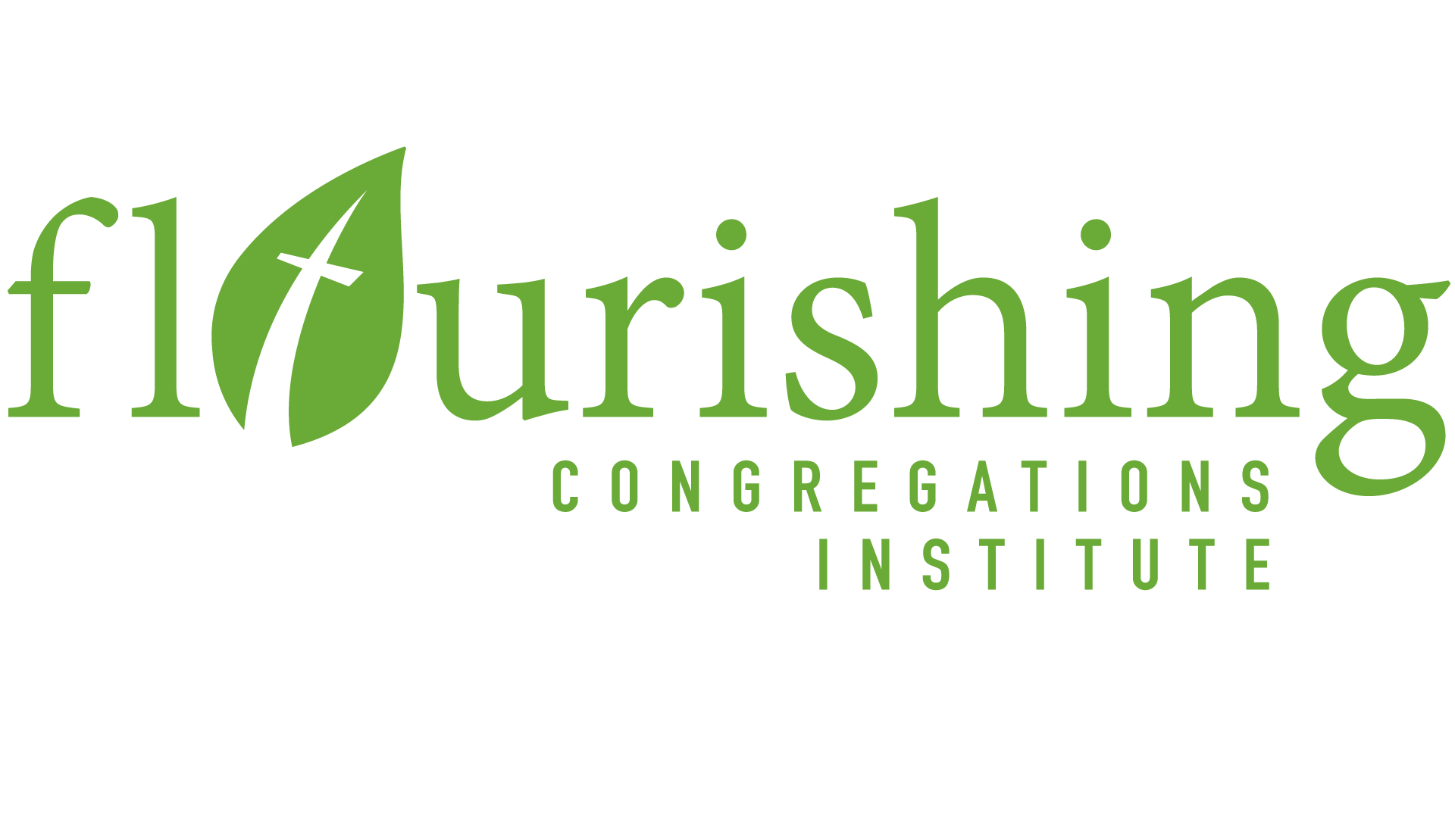
We encourage everyone to check their email for the survey link, and to take some time in the coming week to complete the survey.

