Imagine if all churches could be strengthened across Canada, ours included. Our congregation has partnered with the Flourishing Congregations Institute to be part of this transformation, and we would like your help! Please take 20-minutes to fill out an anonymous national online survey at [insert congregation-specific link]. We hope for 50% or more of our adult attenders to fill out the 20 minute survey. With strong survey involvement, we will access data unique to our congregation/parish.

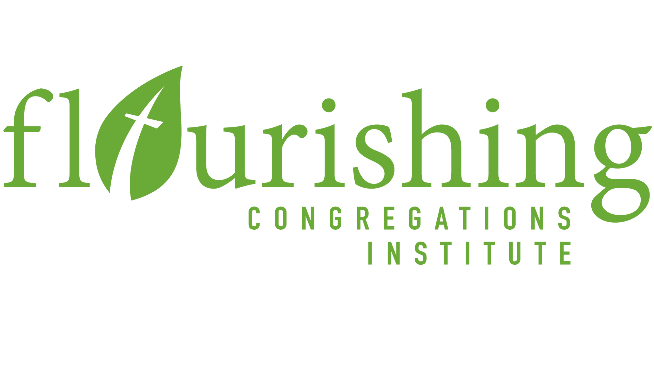
To learn more about the survey, the larger project, and many of the anticipated benefits to arise, visit www.flourishingcongregations.org/national-survey. Thanks, in advance, for completing this survey!

